Radar Animation HMI for Major Gauges - CGEA 1.3

Functional Description

This feature applies to a cluster with virtual major gauges (such as Speedometer/Tachometer and/or HEV Power gauges). The first application is MY20 on the SX cluster, which has a 12.4” TFT display.

As the speedometer and tachometer virtual pointers move, there is an animation that grows as the pointer ascends. This is called the “Radar Theme for Major Gauges”, which resembles radar images and gets longer and brighter the faster the pointers move. The radar animation will also turn red on the tach when the tach soft cutout point for the engine is reached.

This function is mostly HMI, with a few places where we want to provide clarification. The STSS and the wallpapers/animations from HMI all tie together to describe this feature fully.

Interfaces

Interface Context Diagram (I/O Block Diagram)
Figure 1.1 Radar Theme Animation HMI Context Diagram
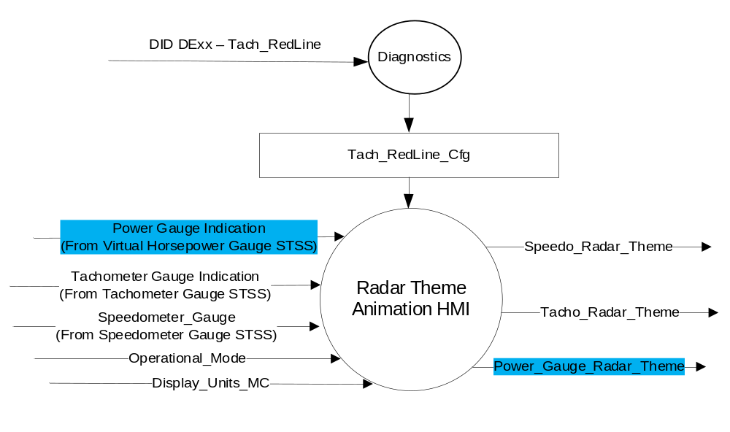

Inputs
- INTERNAL:
  - Operational_Mode
  - Display_Units_MC
  - Tachometer Gauge Indication (Refer to Tachometer Gauge - CGEA1.3 STSS)
  - Speedometer_Gauge (Refer to Speedometer Gauge - CGEA1.3 STSS)

Outputs
- Speedo_Radar_Theme
- Tacho_ Radar_Theme

Function/Performance

Operational Modes

Mode | Differentiating Vehicle Conditions
Sleep Mode | Radar Theme Animation Off
Limited Mode | Radar Theme Animation Off
Normal Mode | Radar Theme Animation Functioning
Crank Mode | Radar Theme Animation Functioning

Voltage Levels

Refer to Cluster Features table located in Operational Modes and Voltage Range Strategies Section in this SPSS.

Human-Machine Interface

Visual

Indicator Graphics / Display Format
Example of Radar Theme at maximum brightness
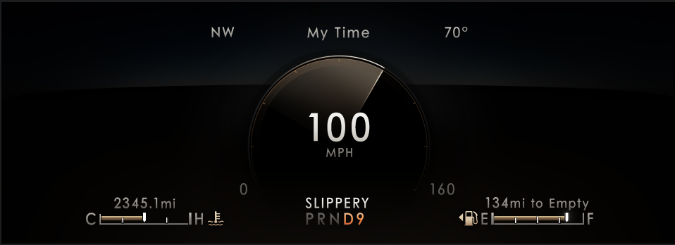

Example of Radar Theme at minimum brightness
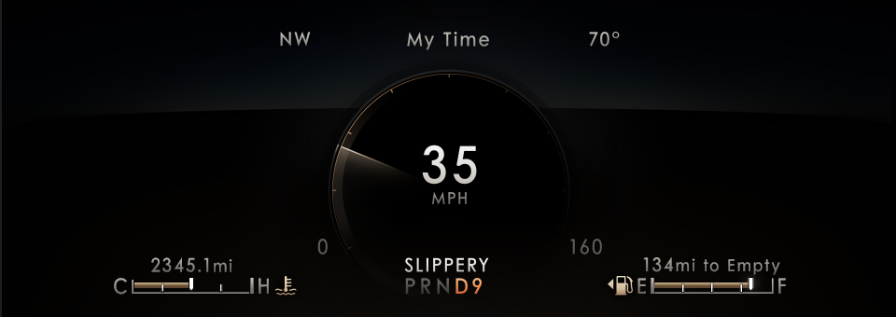

Above are example graphics.
Actual graphics are to be provided by Ford HMI or Studio and approved by the DI Application for each program.

Indicator Color Coordinates

Reference Ford HMI or Studio Wallpaper files for the specific program.

Indicator Characteristics

Reference Ford HMI or Studio Wallpaper files for the specific program.

Audio

None

Switch Control Logic

None

System Accuracy

Within a 100msec of receiving a message that results in a change of state the cluster will update the display to the proper status.

Operation: Performance and Functional

Subsystem Algorithm Flowchart / State Diagram

Maximum Size of Radar Theme
- The following defines the largest size of the gradient from its starting point. If the needle moves any further, it will drag the radar “tail” in its maximum size behind it. It is expected that the supplier shall translate the angular degrees into percentage of gauge travel.
  - ~110° total (All gauges – Speedo, Tach, Horsepower gauge)
Example:
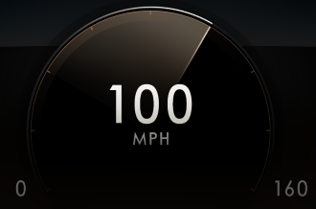

Minimum Size of Radar Theme
- The following defines the smallest possible size of the gradient when the needle is above 45 angular degrees of travel from origin. It is expected that the supplier shall translate the angular degrees into percentage of gauge travel.
  - ~45° total (All gauges – Speedo, Tach, Horsepower gauge)
  - At less than 45 angular degrees from origin, the gradient is compressed completely starting from 0
Example:
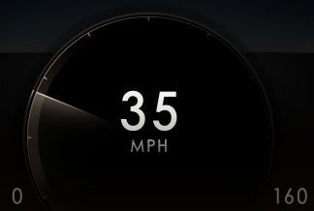

- Whenever the pointer is not moving or has minimal motion, the radar “tail” collapses to the minimum size.
  - Minimal or no acceleration can be specified as follows:
    - Pointer is not moving more than 3 angular degrees per second
    - Radar “tail” collapses to minimum size after timeout of 1 second (needle did not move more than 3 angular degrees)
    - It will stay in this size until the pointer starts accelerating more than 3 angular degrees / s (see HMI animation)

Color of Radar Theme
- The Color is dependent on Studio provided graphics
  - The exact color, brightness and gradient properties can be extracted from Photoshop deliveries
  - The radar theme in its fundamental state is a champagne color to transparent gradient; any color is dynamically applied
- For the Tacho gauge only: When above the the tach soft cutout point for the engine, the color is changed to red.
  - The tach color is changed to red when the tachometer gauge indication is in the range defined by the DExx parameter Tach_Redline_Cfg.
Example:
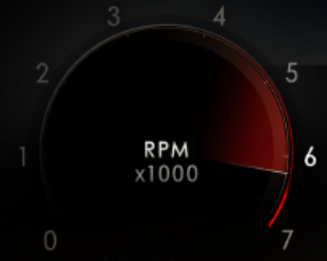

- For the PHEV Power gauge only: The color changes based on mode (EV engine, ICE engine, Charging – See Horsepower Gauge STSS for details of colors).
  - The Horsepower Gauge has blue fill for EV, gray for ICE, and green for charging.
Example:
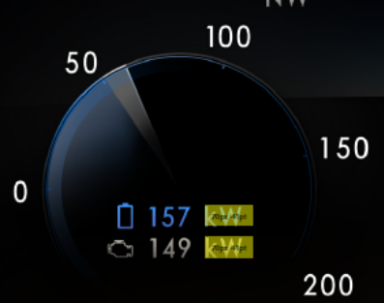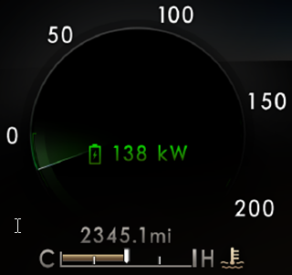

Brightness/Intensity of Radar Theme
- The brightness or intensity of the Radar “tail” depends on the pointer’s current acceleration (not the car’s acceleration)
- There is a dark gradient at 0 rotations per second that gradually becomes brighter with increasing needle speed.
- The gradient reaches its brightest tone at maximum rotation.
- Maximum rotation is set per WOT (Wide Open Throttle) on an engine type. We shall protect for 2 engine types, corresponding to the Tach_Redline_Cfg as per the table below:

Tach_Redline_Cfg | Rate of Change in RPM for max Tacho brightness  (RPM_ROC) | Rate of Change in km/h for max Speedo brightness | Rate of Change in kW/sec for max Power Gauge brightness
Range 0x1 | 5000 RPM/s (RPM_ROC_1) | 6 mph/s (SPEED_ROC_1)  (note: Corresponds to 0-60 mph in 10.0s) | 160kW/0.5s
Range 0x2 or Range 0x3 | 5000 RPM/s (RPM_ROC_2) | 6 mph/s (SPEED_ROC_2)  (note: Corresponds to 0-60 mph in 10.0s) | 160kW/0.5s

- The 4 Rate of Change parameters in the table above shall be NVM programmable during prototype build phase and shall be accessible to Ford. Preferred implementation is as a Supplier Range writable DID. Exact definition of parameter left to supplier discretion.

- The darkest gradient at zero rotation speed shall vary from R:5 to R:45, G:5 to G:39, and B:4 to B:31.
Example:

- The brightest gradient at maximum rotation speed shall vary from R:5 to R:86, G:5 to G:78, and B:4 to B:66.
Example:
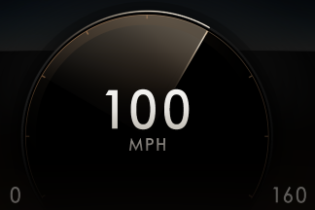

Deceleration of Radar Theme
Whenever the pointer is moving counter-clockwise on a slow pace, after accelerating slowly, the radar “tail” collapses to the minimum size with an animation. (For example, while not pushing the gas pedal or slow braking after modest acceleration.)
- While on a slow deceleration, the radar “tail” collapses to the minimum size with an animation.
- A slow deceleration is defined as a decel < 10 angular degrees / s.
- During prototype phase, the supplier shall implement the slow deceleration parameter as a Supplier Range writable DID.
- While moving “backwards” with the needle, it will always keep the minimum size.
- It will stay in this size until the pointer starts accelerating more than 3 angular degrees / s.

Whenever the pointer is moving counter-clockwise on a fast pace, the comet tail is replaced immediately with the minimum size radar “tail”, without any collapsing animation.
(For example, when braking hard after strong acceleration.)
- While on a fast deceleration, the radar “tail” collapses to the minimum size without animation.
- A fast deceleration is defined as a decel >= 10 angular degrees / s. (i.e. “Not slow decel”)
- While moving “backwards” with the needle, it will always keep the minimum size.
- It will stay in this size until the pointer starts accelerating more than 3 angular degrees / s.

Operation Description (supports algorithm flowchart /state diagram)

Function Safety Classification (EMC)

Class B

Memory Storage
Parameter Name | Description | Value at Battery connect | Value at  Module Wake-up
Display_Units_MC | Input to this routine that controls display indicating units to the driver (i.e. when English: miles, mpg; when Metric: km, L/100 km, km/L). Parameter is to be stored in Battery Backed RAM. | Used Stored Value (See Display Unit Selection Control Function STSS) | Do Not Init
Operational_Mode | Input to this routine that is a 4 State indicator for cluster operational mode | As per Operational Modes and Voltage Range Strategies Section (STSS) | As per Operational Modes and Voltage Range Strategies Section (STSS)

Prove Out

Not applicable.

Reconfigurable Telltale

Not applicable.

Message Center Msg

Refer to text as defined in the Text Translation file

Error Handling

Missing Message Strategy

None

Invalid Data Strategy

None

Diagnostics

Self Test

None

Engineering Test Mode

Reference section “Dealer / Engineering Test Mode (ETM)”

Part II Performance

Supported Diagnostic Trouble Codes (DTCs)
DTC | Description
None

Supplier Range read/write DIDs during protype builds:
DID | Description
RPM_ROC_1 | Defined in section 1.3.5.1.4 Brightness/Intensity of Radar Theme
RPM_ROC_2 | Defined in section 1.3.5.1.4 Brightness/Intensity of Radar Theme
Speed_ROC_1 | Defined in section 1.3.5.1.4 Brightness/Intensity of Radar Theme
Speed_ROC_2 | Defined in section 1.3.5.1.4 Brightness/Intensity of Radar Theme
Slow Decel Threshold | Defined in section 1.3.5.1.5 Deceleration of Radar Theme

DID DExx
Bit(s) | State: Description | "0" | “1” | “2” | "3" | Default | Comments/  Information
2 | Tach_RedLine | No Redline | Range 1 | Range 2 | Range 3 | 0x1 (Range 1) | Used by IPCs that have virtual tachometers.  This parameter defined in Tachometer Gauge – CGEA 1.3 STSS.

Reference Specification
IS-0344 GENERAL REQUIREMENTS (MSGCENTR)
IS-0379 NORTH AMERICAN WARNINGS AND INDICATORS STRATEGY

- Appropriate Program Specific Text Translation File
- Appropriate Program Specific IPC Menu Structure File

Revision History

SPSS Module Revision History

Revision Level | Name | Change Description | Date
1.0 | S. Watkins | Initial release with input from Mack Dobbie speaking for Craig Sandvig | 1/16/2018
1.1 | H. Sharma | This update takes care supplier’s request to add Rate of Change in kW defined for max Power Gauge brightness. Changes are marked in Turquoise color.  - Section 1.2.1, Context diagram updated.  - Section 1.3.5.1.3 Color of Radar Theme updated to match latest HMI deliveries.  - Section 1.3.5.1.4 Brightness/Intensity of Radar Theme  updated to add Rate of Change for power gauge. | 03/11/2019

